International Workshop on  75 Years of λ-Calculus  University of St Andrews, Scotland  15th June, 2012  Call for Participation  http://msp.cis.strath.ac.uk/lambda2012 | 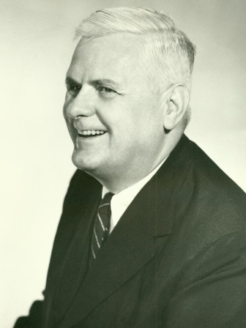

Overview
In 1936, Alonzo Church’s foundational “An unsolvable problem of elementary number theory” introduced the λ-calculus which, with Turing machines, now underpins contemporary theoretical and practical Computer Science. To celebrate the 75th anniversary of the publication of this seminal work, participation is invited at a one day International Workshop, to be held in St Andrews on 15th June 2012, immediately following the International Symposium on Trends in Functional Programming (TFP).

Programme
10.00 Introduction
10.15 Invited speaker: Roger Hindley, University of Swansea, Before 1936, the impure λ-calculus
11.00 Jonathan Seldin, University of Lethbridge, Curry's influence on the early history of λ-calculus
11.30 Invited speaker: Fairouz Kamareddine, Heriot-Watt University, The λ-calculus a la de Bruijn
12.15 lunch
13.15 Patrik Eklund and Robert Helgesson, Umea University, Modern eyes on λ terms
13.45 Invited speaker: Chris Hankin, Imperial College London, Operational semantics and abstract machines
14.30 break
15.00 Daniel Ventura, Mauricio Ayala-Rincon and Fairouz Kamareddine, Universidade Federal de Goias/Universidade de Brasilia/Heriot-Watt University, Intersection types and explicit substitution: an overview
15.30 Invited speaker: Henk Barendregt, Radboud University, Nijmegen, λ-calculus and its view on infinity
16.15 close

Workshop Chairs
Greg Michaelson, Heriot-Watt University
Patricia Johann, University of Strathclyde

Programme Committee
Robert Atkey, University of Strathclyde
Dan Dougherty, WPI
Maribel Fernandez, Kings College London
Philip Scott, University of Ottawa

Registration
The fee is £50, including refreshments and lunch.

There is no charge for PhD students from SICSA-affiliated Universities.

To register, please follow the link:

http://onlineshop.st-andrews.ac.uk/browse/extra_info.asp?compid=1&catid=34&modid=2&prodid=247&deptid=29&prodvarid=0

and select the first option: TFP Affiliated Workshop Registration (if not registering for TFP).

